**Ideation Phase**

**Define the Problem Statements**

|  |  |
| --- | --- |
| Date | 20 September 2022 |
| Team ID | PNT2022TMID24784 |
| Project Name | Project - Signs with smart connectivity for better road safety |
| Maximum Marks | 2 Marks |

# Signs with smart connectivity for better road safety :

With the use of smart signs, which can modify speed limits based on the climate and weather, display diversion information in the event of an accident, and display alert messages in the event of hospitals, schools, or roadwork, static signs will be replaced.

Smart connected sign boards are used to replace static signboards. These intelligent connected sign boards update automatically and obtain the speed restrictions from a web application utilizing weather API. The speed may increase or decrease based on changes in the weather. The display of the diversion signs depends on the flow of traffic and potential fatalities. The appropriate guide, warning, and service signs are also visible at hospitals and restaurants. With the use of buttons, many operating modes can be chosen.

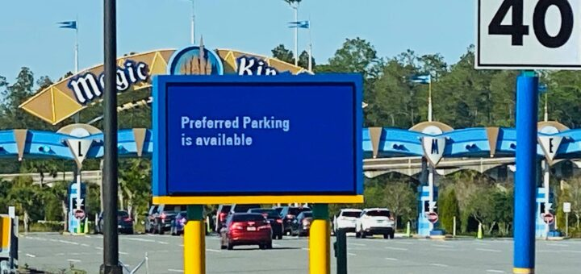

Road signs play the most important function in ensuring traffic safety, as we all know. However, under specific circumstances, the signs may be modified. If there are road diversions brought on by high traffic or accidents, we can take those into consideration and, if the signs are digital, modify them to reflect the situation. This proposal suggests a system that uses digital sign boards with constantly changing signs. The roads will be slick and dangerous if it rains.

There would be a lower speed restriction. There is a web application that allows you to enter information about road detours, accident-prone regions, and informational sign boards. This information is obtained.

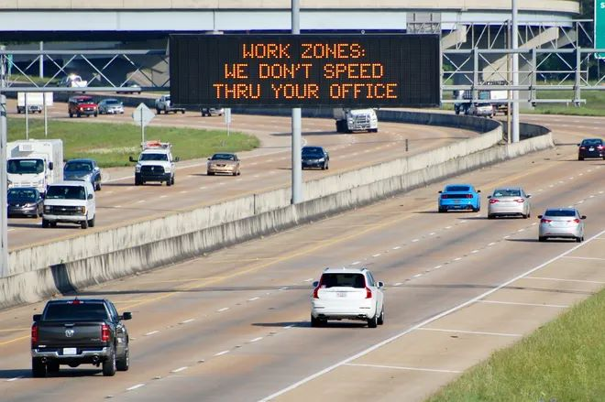

# References :

1. J. Greenhalgh and M. Mirmehdi, “Recognizing text-based traffic signs,” IEEE Transactions on Intelligent Transportation Systems, vol. 16, no. 3, pp.1360-1369, 2015.
2. Y. Yang, H. Luo, H. Xu, and F. Wu, “Towards real-time traffic sign detection and classification,” IEEE Transactions on Intelligent Trans portation Systems, vol.17, no. 7,pp. 2022-2031, 2016.
3. J.Jin, K.Fu, and C. Zhang, “Traffic sign recognition with hinge loss trained convolutional neural networks,” IEEE Transactions on Intelligent Transportation Systems, vol.15, no. 5, pp. 1991-2000, 2014.
4. X.Lu, Y.Wang, X. Zhou, Z. Zhang, and Z. Ling, “Traffic sign recognition via multi-modal tree-structure embedded multi-task learning,” IEEE Transactions on Intelligent Transportation Systems, vol.18, no. 4, pp.960-972, 2017.